Summary of Pediatric/Adolescent Development (10pts)
A summary of the information on various aspects of development from your textbook/online resources. You should include reflexes, functional abilities, psychosocial development, etc Specifically address how interventions and communication should be tailor to this population. Possible examples: role of parent, school based therapy, play based therapy, etc..
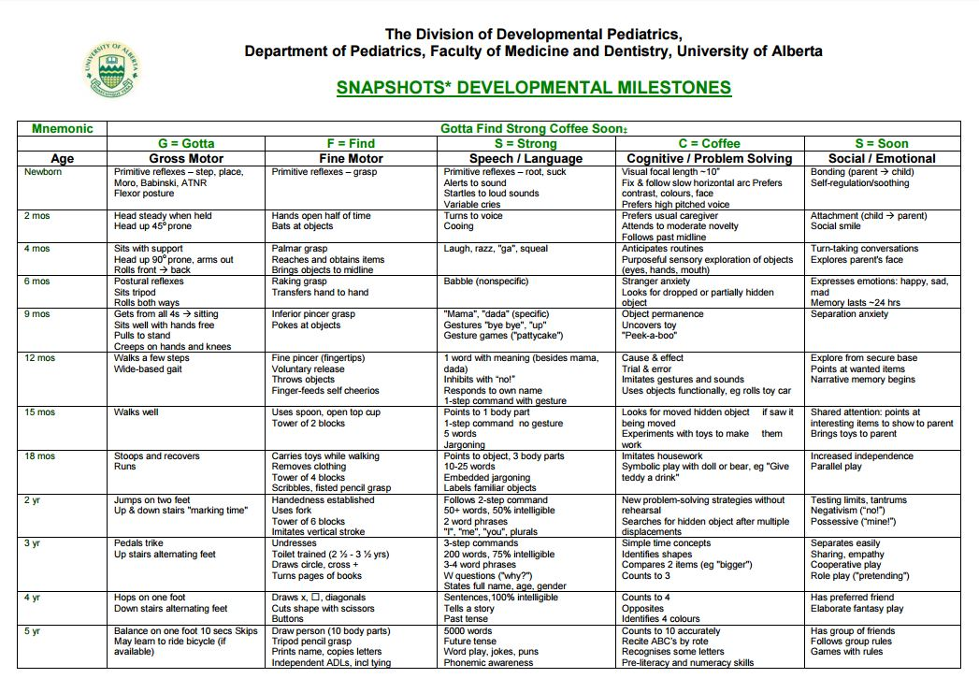
During the early years of adolescent development, they are just starting to begin to grasp the concept of abstract/ logical thought. They are just starting to think about ones actions and what affect it will have on others. This enhanced awareness will often turn into self-consciousness and can lead to the feeling of awkwardness. One’s moral code is also starting to develop during this stage. Before, they were always told what was right and what was wrong by their parents but now they are starting to decide that for themselves.
During school, they are starting to see schoolwork that is more challenging and they often begin to see areas that they are strong at and areas they are weak at. With that being said, clinicians and parents need to be aware of the child’s capabilities and if any are present, identify impediments. If there are any impediments to learning, then the parents and clinicians can take the right course of action to help to child get whatever help they may need to receive the best education they can.
Physical Therapy when working with this type of group should be focused more on play and games rather than exercises. What this does is that it gets the child involved and more active in wanting to do physical therapy. If we make it a game when doing exercises then the child is more likely to participate and give more effort. We should also direct treatment to activities that the child likes to do to improve involvement. Overall, Physical Therapy should be directed to what each child enjoys and what will get them to participate as well.

References:
(n.d.). Retrieved from https://www.pedscases.com/developmental-milestones
Adolescent Development - Pediatrics. (n.d.). Retrieved from https://www.merckmanuals.com/professional/pediatrics/growth-and-development/adolescent-development

