Summary of didactic education for this population (20 pts)
Summarize didactic course work and provide 2-3 artifacts with a description of how each it demonstrates mastery of the covered course competencies for the pediatric/adolescent population. Include a summary of service learning opportunities working with this population.
Include course, Course # & Assignment/Assessment Title) Try to show development by using a 1st year course and a 2nd year course.
List and describe each artifact and explain how it demonstrates mastery of this competency. Attach or copy the artifact in the e-portfolio.
(Include a minimum of two textbook references)

Artifact 1: Functional Five Movement Screen (Therapeutic Exercise #21031)

For the first artifact, we as a class went over to Parkview Middle School for a couple days to assess and see the functional development of the middle school students. Below are all the 5 components that make up the screen and goes further into detail about each one individually.
Functional Five Movement Screen
SCORING OVERVIEW:
The scoring rubric helps breaks down each movement into 3 levels. If students are scored at a level 2, their movement pattern is proficient. These students have mastered this baseline movement enough to add more advanced movements to it. Level 3 is the highest score possible. It is not easy to perform. Most kids will not make it into this category and why it is classified as advanced. If students score at a level 1, they need some extra support to re train the functional movement pattern screened. The corrective exercise programming will help students reestablish the mobility, stability or coordination movement pattern weaknesses.
SCORING LEVELS:
Level 3 – Advanced
Level 2 – Proficient
Level 1 – Developing
DYNAMIC KNEE STABILITY – DYNAMIC BALANCE
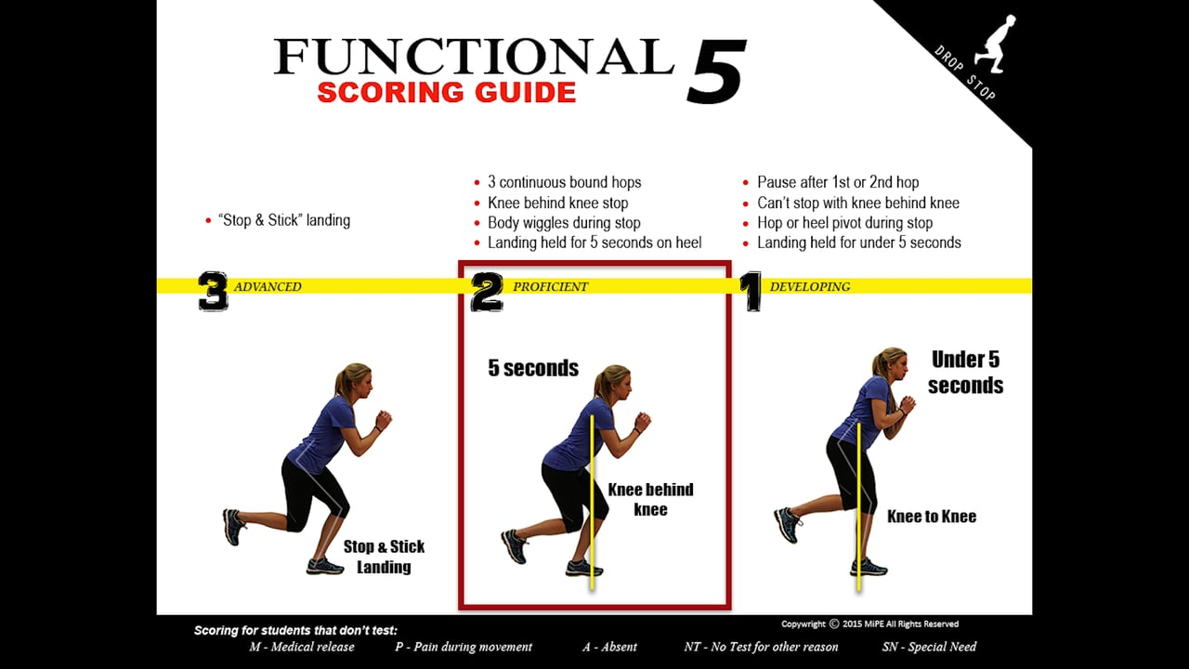
SET-UP DETAILS:
- Students stand on the 9 foot line
- On command, the students hop forward 3 times without pausing
- After the third hop, the students bend and stop
- The landing is held for 5 seconds
- After the first attempt, the students turn around and perform the same movement again
- Two attempts are given on each leg to achieve the highest score
SQUAT SCREEN – ANTERIOR HIP MOBILITY
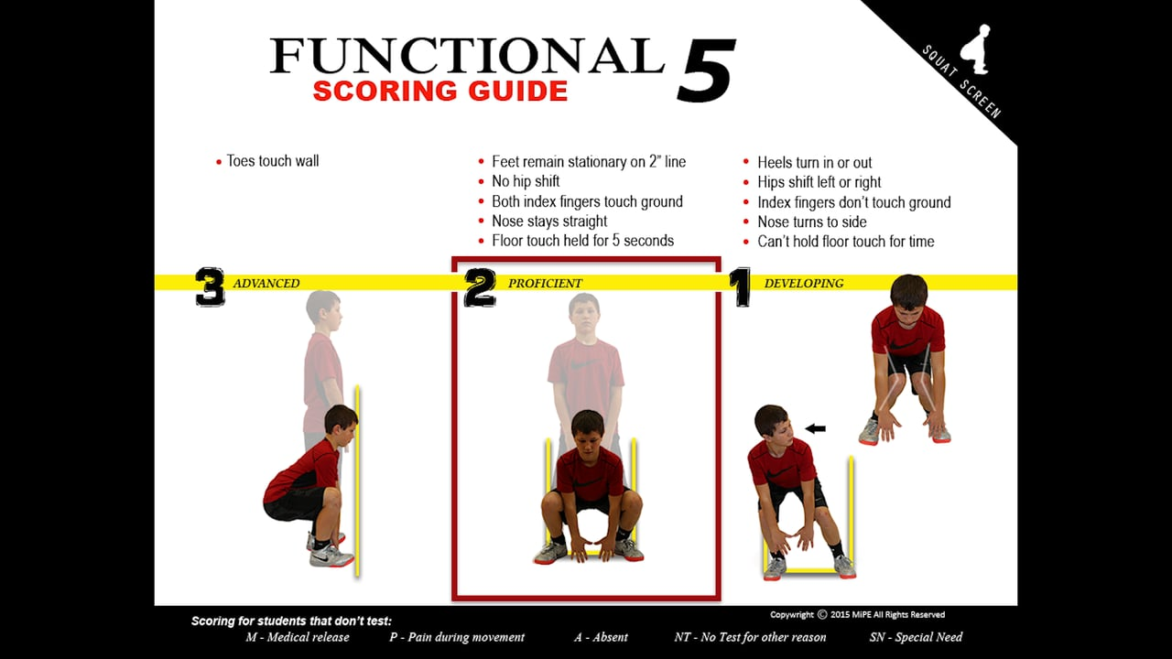
SET-UP DETAILS:
- Students walk up to the wall and place both feet behind the two-inch line
- Feet are shoulder width apart with the toes straight
- Hands point down with the thumbs touching
- On the teachers command, students bend down and touch the ground between the feet
- The position is held for 5 seconds with both index fingers touching the ground
- Once the downward movement is complete, students stand back up and hold the finish for 2 seconds
LEVEL 3 SET-UP DETAILS:
- Students walk up and place both toes against the wall.
- Feet are shoulder width apart with the toes straight
- Hands point down with the thumbs touching
- On the teachers command, student’s bend down and touch the ground between the feet
- The position is held for 5 seconds with both index fingers touching the ground
- Once the downward movement is complete, student’s stand back up and hold the finish for 2 seconds
HIP HINGE – POSTERIOR HIP MOBILITY
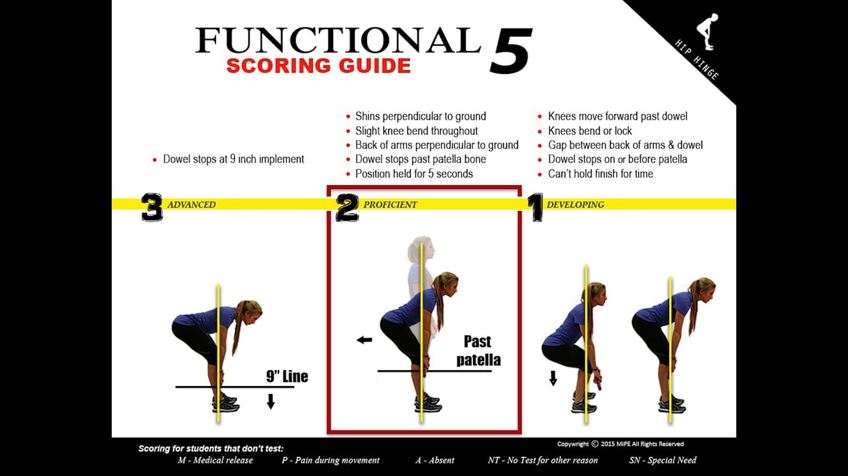
SET-UP DETAILS:
- The students stand nice and tall
- Feet are shoulder width apart with the toes straight
- Knees are and must remain slightly bent
- The students grip the dowel just outside the legs
- The dowel is placed on the quads
- On command, students bend at the hips and slide the dowel down the legs
- The movement stops when the dowel moves past the knees
- The position is held for 5 seconds
- Students then return to the starting position
LEVEL 3 SET-UP DETAILS:
- The students stand nice and tall
- Feet are shoulder width apart with the toes straight
- Knees are and must remain slightly bent
- The students grip the dowel just outside the legs
- The dowel is placed on the quads
- On command, students bend at the hips and slide the dowel down the legs
- The movement stops when the dowel contacts a 9 inch implement
- The position is held for 5 seconds
- Students then return to the starting position
CORE STABILITY – POSTURE SCREEN
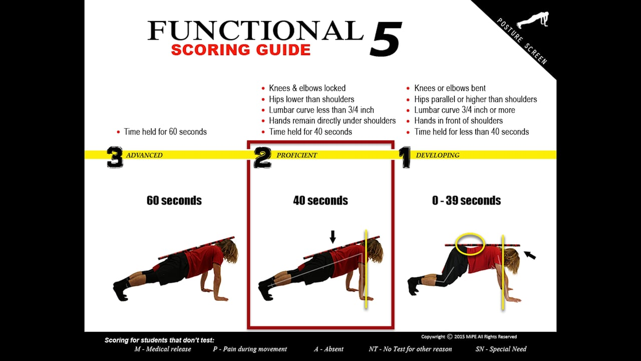
SET-UP DETAILS:
- Students set-up on all fours
- Knees are bent
- Hands are placed directly below the shoulders
- The chin is tucked
- A dowel is placed on the head, upper back & tailbone
- On command, students raise and lock the knees keeping the hips lower than the shoulders
- Students hold for time
MOVEMENT ADEQUACY – SKIP SCREEN
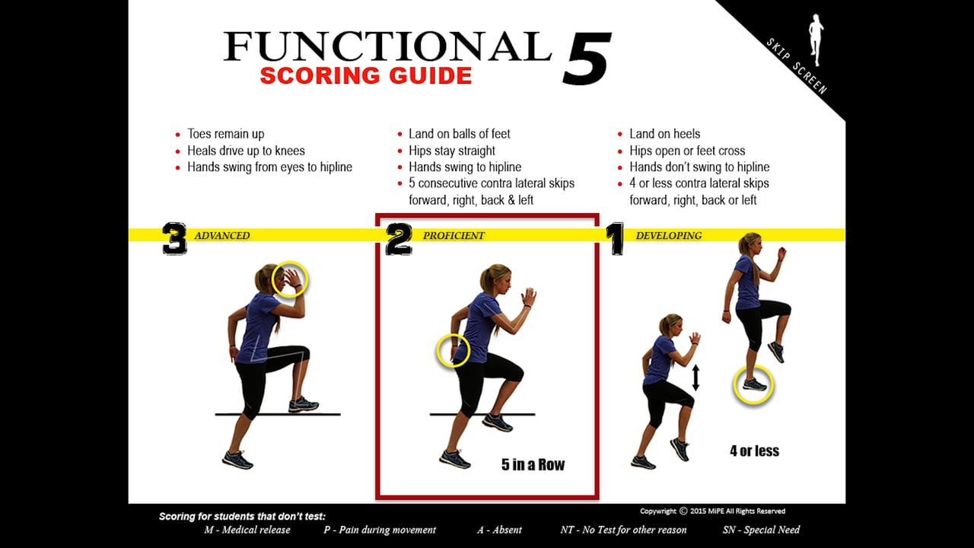
SET-UP DETAILS:
- Students stand nice and tall.
- On command, students skip forward, right, backward and left 5 times in each direction
SCORING OVERVIEW:
The scoring rubric helps breaks down each movement into 3 levels. If students are scored at a level 2, their movement pattern is proficient. These students have mastered this baseline movement enough to add more advanced movements to it. Level 3 is the highest score possible. It is not easy to perform. Most kids will not make it into this category and why it is classified as advanced. If students score at a level 1, they need some extra support to re train the functional movement pattern screened. The corrective exercise programming will help students reestablish the mobility, stability or coordination movement pattern weaknesses.
Competencies:
- #1 Integrate concepts of pathology, PT intervention and data collection for application to adolescent population (7D2, 7D4, 7D5, 7D8, 7D16, & 7D29)
- #5 Differentiate typical/atypical development (7D24i)
- #6 Describe development tests used to assess children (7D24i)
- #7 Explore the role of the PTA in the promotion of health & wellness and prevention for the pediatric & adolescent population (7D24m)

Artifact 2: HEP for Middle School Student (Musculo Rehab #81550)
HEP for Middle School Student
Since my student scored 1’s on each of the tests, I had to make his HEP very simple to do and start off with the basics.
HEP #4: Jacob G

Hamstring Stretch with Towel

While lying down on your back, hook a towel or strap under your foot and draw up your leg until a stretch is felt under your leg/calf area.

Keep your knee in a straightened position during the stretch and hold for 30 seconds
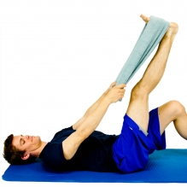

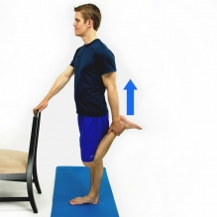
Quad Stretch

While in a standing position, bend your knee back behind and hold your ankle/foot. Next gently pull your knee into a more bent position until a stretch is felt on the front of the thigh.

Hold for 30 seconds and then switch to the other leg.

Single Leg Stance

Stand on one leg and maintain your balance

Hold for 30 seconds and then switch to the other leg.
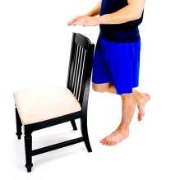
Modified Plank Plus

Perform a plank on your knees and elbows as shown.

Hold for 30 seconds and then relax. Do 3 sets of 30 seconds.
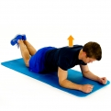

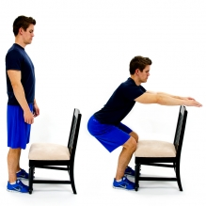
Squat – Chair as Guide

While standing with your feet shoulder width apart and in front of the chair that is facing you, Bend your knees and lower your body towards the floor. The chair seat is a guide so that your knees do not pass over your toes.

Do 3 sets of 6 reps

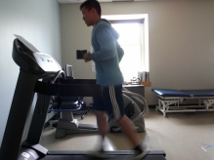
Running on a treadmill or around the block

Jog for 10 min.

Do this twice a day.

Reflection:
I decided to educate Jacob and his parents on how to stay active as a kid. I believe it’s very important, especially in today’s world with all the electronics and gaming systems out there that kids are not being as active as they used to be and is causing a lot of problems health wise. The reasons why I chose these exercises was because my kid scored all 1 on the functional 5 tests. This could be due to lack of effort or because he truly scored all 1’s. To start him off, I gave him a couple of stretching exercises so that he can improve his range of motion and mobility so that he can have more success the next time he is tested for the functional 5. I also have him working on balance exercise so that he can improve on his drop step. I also have him working on his core with the mini plank so that he can start to learn good form first. Lastly, I have a jogging program for him so he can start to improve in cardiovascular system and be ready for the pacer test.
If Jacob said they are doing okay with the exercises that was sent home with them, I would start to progress these exercises. I would do this by either increasing the reps and sets for the exercises that it applies to or increase the time. I believe for Jacob, he needs to work on more stretching and mobility exercises as well as improving the cardiovascular systems if he wants to see improvement in his scores.

Competencies:
- #2 Integrate concepts of pathology, PT interventions and data collection for application to adolescent populations. (7D2, 7D4, 7D5, 7D8, 7D16, 7D29)
- #7 Explore the role the role of the PTA in promotion of health & wellness and prevention for the pediatric & adolescent population (7D24m)
- #9 Explore physical therapy interventions for special patient populations. (7D2, 7D4, 7D5, 7D8, 7D16, 7D24e,7D29)

