Summary of didactic education for this population (20pts)
Summarize didactic course work and provides 2-3 artifacts with a description of how each it demonstrates mastery of the covered course competencies for the Older Adult population. Include a summary of service learning opportunities working with this population. Include course, Course # & Assignment/Assessment Title) Try to show development by using a 1st year course and a 2nd year course.
Include course, Course # & Assignment/Assessment Title) Try to show development by using a 1st year course and a 2nd year course.
List and describe each artifact and explain how it demonstrates mastery of this competency. Attach or copy the artifact in the e-portfolio.

Keep stepping Handout
I chose to do the keep stepping handpout as my first artifact because both of my clients that I worked with were in the geriatric population and I was really able to get close and work with each person one on one. I was able to figure out what impairment each one had and ways to go about correcting it or to strengthening it. This was over the course of a semester with each patient and I not only was I able to see progress in each patient but they did as well. The course competencies covered for this project are listed below.

PTA Applied Kinesiology #81040
Competencies:
- Explore the role the role of the PTA in promotion of health & wellness and prevention for the adult population (7D24m)
- Explore physical therapy interventions for special patient populations. (7D2, 7D4, 7D5, 7D8, 7D16, 7D24e,7D29)

What is a Circuit
- Circuit training is where we will have 6 differents stations with a different exercise at each station. At each station you will work out for 1 min. and 30 sec then have 45 sec. to move to the next station. 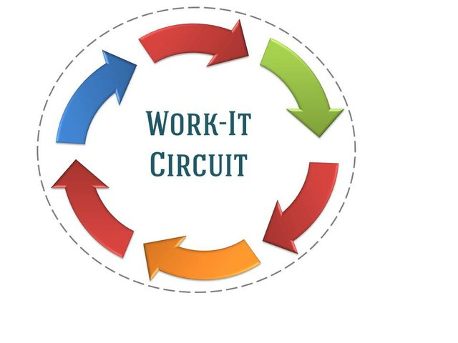
Benefits of Circuit Training
- A circuit based exercise program is designed to get you up and moving, to get your heart rate up, along with strengthening.
- With different types of training it keeps you active so you won’t get bored.
- It is a great way to incorporate a full body workout in a limited amount of time.
Station 1: Upper Extremity Strength
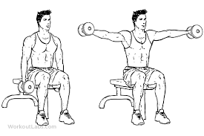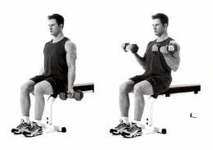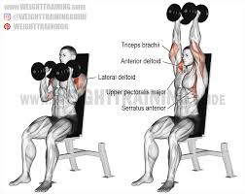
Station 2: Lower Extremity Strength
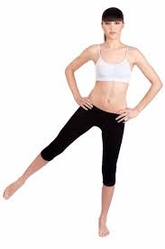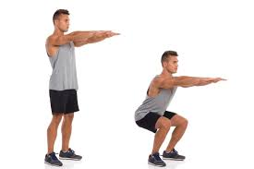
Station 3: Core Strength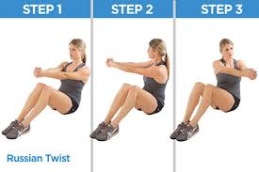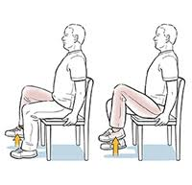

Station 4: Balance and Coordination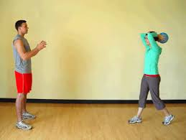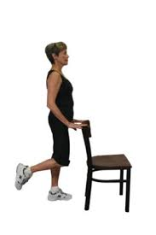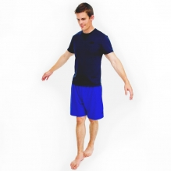

Station 5: Cardio Endurance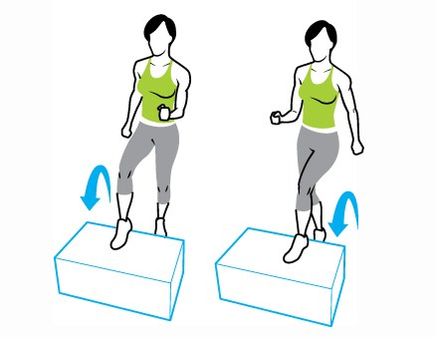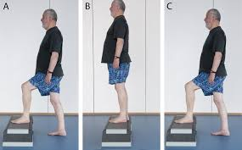

Station 6: Back Strength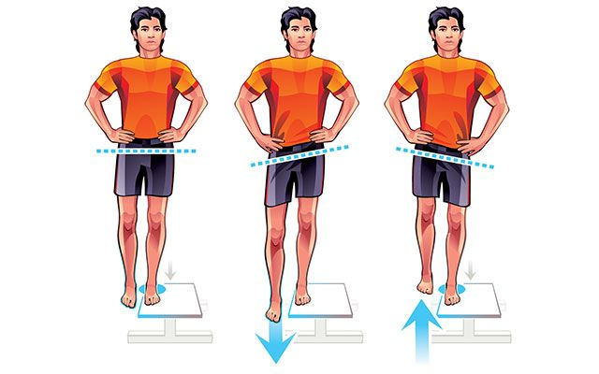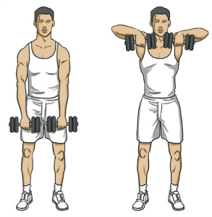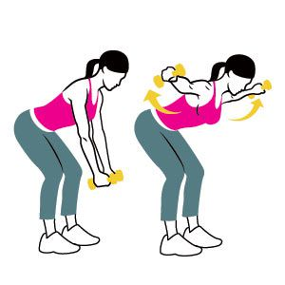

Home Assessment
The second artifact that I chose was the home assessment I did on my grandma and her house. This fits perfectly with the geriatric portion because she is 85 years old and has possible safety issues with her house. After going through it with her and being able to show her simple fixes that didn’t need a lot of money, both she and I were able to see improvements. These improvements helped to make her safer in her own house for when I am gone next year back in Arizona. The course competencies covered for this project are listed below.
PTA Rehab Across the Lifespan #21117
Competencies:
- Explore the role the role of the PTA in promotion of health & wellness and prevention for the adult population (7D24m)
- Explore physical therapy interventions for special patient populations. (7D2, 7D4, 7D5, 7D8, 7D16, 7D24e,7D29)

Casey Tompa
Home Assessment
Rehab Across the Lifespan
4/25/2019
Home Assessment
I decided to do my home assessment on my grandmother’s house in Green Bay. My grandma is 85 years old and currently lives with me in a two-story house that is made up of the first floor and the basement. My grandmas past medically history is that she has had breast cancer and blot clots before. She is now cancer free but is on warfarin, which is a blood thinner so that a blot clot does not develop again. Sadly with her old age, her memory isn’t the best at all and often forgets to do a lot of things whether its going to appointments or what my schedule is since I am currently living with her in the basement while I am out here for school. I have to repeat myself several times if I have to go to the clinic down in Sheboygan today or to my job that I work on the weekends at 1919 Kitchen & Tap. Mobility and strength wise, she has no impairments but cognitively there are. The home assessment tool that I used is called a “Safe at Home Checklist”.
The first problem that I saw the house had to do with her bathroom, specifically the bathtub. To get into the bathtub, it is a high step over and I often hear my grandma complain about it when she has to take a shower. A simple solution to fix this would be to add a small step stool in with added handrails for security. An expensive solution would be to tear down the old bathroom and put in a step in shower with a shower seat for her to sit in so she doesn’t have to stand the whole time. This eliminates the need to step over to get in and allows her to sit down which can help with stability.
The next problem that saw had to with the kitchen. First, I opened the cabinet under the sink to find that the pipes were not covered or insulated. There is a simple fix to this which is to cover the pipes with the correct material needed. An expensive solution is not required for this. Another problem that I saw is the rug in front of the sink, which is really thick and I have seen my grandma trip over it numerous times. Not only that but it never stays in place and moves around quite easily. A quick fix to this would be to apply double sided tape or non slip pads on the corners of the rug so that it doesn’t move around on her. An expensive route could be to go out and get a new rug altogether that is not as thick and comes with stick pads.
The last big problem I noticed had to do with the basement. To get down into the basement, the stairs are poorly lit because there is light only at the top and bottom of the stairs and not middle. Thankfully grandma hasn’t taken a tumble down the stairs but a light should be added in the middle. There is not really a cheap option to do this since an electrical wire would have to be made and cut into the ceiling to allow for an extra light fixture. The stairs also only have railing on one side and it would be ideal if they were on both sides for extra protection. Lastly is the light in the laundry room/storage area in the basement. This room has only one light and even it tis bright, it only covers the washer and dryer and not storage area. A simple fix to this would be to buy one or two stand up lamps to be able to have more light throughout the room. An expensive fix to this would be to have an electrician install a whole new light system throughout the room.
Overall, my grandma moves pretty well for her age but can have set backs with her memory and her medication. While there were a lot of great ideas on the assessment checklist I used, it is out of the question due to money reasons. For those problems that I could fix with simple/ quick fixes, I did. I enjoyed doing this assignment and going over the possible issues with my grandma so that not only I was aware but she was too.

