What is a Circuit
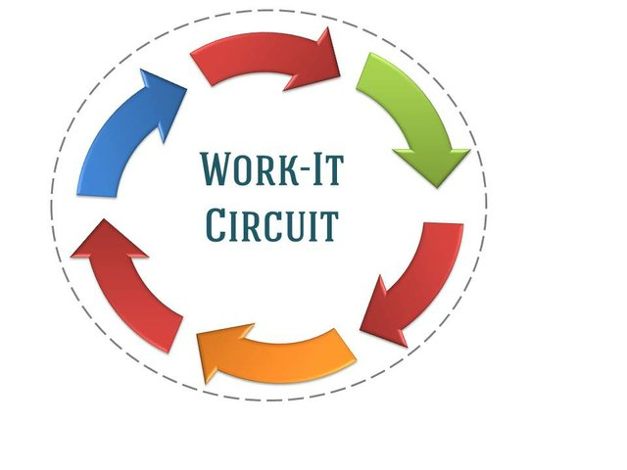
- Circuit training is where we will have 6 differents stations with a different exercise at each station. At each station you will work out for 1 min. and 30 sec then have 45 sec. to move to the next station.
Benefits of Circuit Training
- A circuit based exercise program is designed to get you up and moving, to get your heart rate up, along with strengthening.
- With different types of training it keeps you active so you won’t get bored.
- It is a great way to incorporate a full body workout in a limited amount of time.
Station 1: Upper Extremity Strength
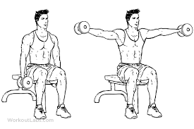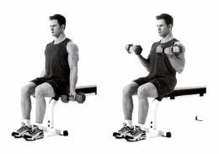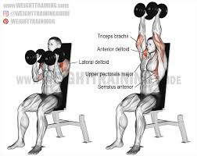
Station 2: Lower Extremity Strength



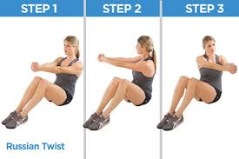
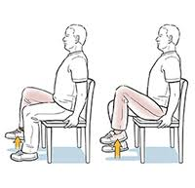
Station 3: Core Strength




Station 4: Balance and Coordination

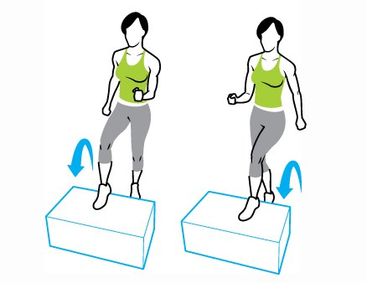
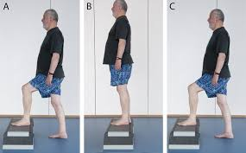
Station 5: Cardio Endurance

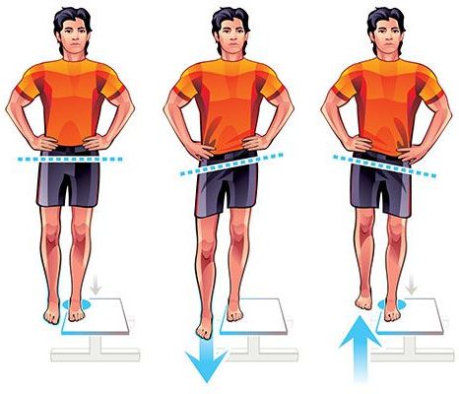
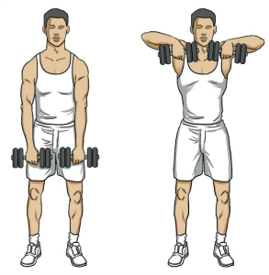

Station 6: Back Strength

