- Pediatric/Adolescent Section
#1 Integrate concepts of pathology, PT interventions, and data collection for application to the pediatric populations. (7D2, 7D4, 7D5, 7D8, 7D16, 7D29)

#2 Integrate concepts of pathology, PT interventions and data collection for application to adolescent populations. (7D2, 7D4, 7D5, 7D8, 7D16, 7D29)

#5 Differentiate typical/atypical development (7D24i)

#6 Describe developmental tests used to assess children (7424i)

#7 Explore the role the role of the PTA in promotion of health & wellness and prevention for the pediatric & adolescent population (7D24m)

#9 Explore physical therapy interventions for special patient populations. (7D2, 7D4, 7D5, 7D8, 7D16, 7D24e,7D29)

Lifespan Systems Approach for the Pediatric & Adolescent Population (Group Project) (10pts)
Describe the major changes, functional implications, rehabilitation implications for each life stage. How with this knowledge be integrated as a PTA when treating patients from this age? (Nervous, Somatosensory, Visual, Vestibular, Muscular, Skeletal Systems)

Nervous System:
Developmental Phase | Major Changes | Functional Implications | Rehabilitation Implications | How will I use this knowledge as a PTA when working with patients of this age?
Maturation (Infancy & Childhood) | Myelination in cerebral hemispheres at the end of the first postnatal month.  -Corticospinal tract myelinated by end of first year, sensory tracts by age 2, frontal/parietal lobes by birth, and occipital lobes shortly after, temporal and frontal lobes in first year.  -Neuronal growth and maturation and with increasing complexity of neuronal process. | Function highly dependent on postnatal sensory and motor experiences.  -Myelination and CNS development close to Piaget’s cognitive stages  -Myelination and development of parietal, occipital, and temporal lobes related to development visual sensorimotor functions  -Critical period for growth to birth | -Neural maturation highly dependent on use of pathway  -Growing into deficit may appear to be the case  -Deficits are displayed during subsequent development when the behavior or lack of functional ability becomes observable. | Recognize that functional ability relates to neural maturation. For example, an infant raised in a stimulating environment will mature earlier than an infant not exposed to stimulation.
Maturation (adolescence) | -Continued brain growth until age 12-15; critical growth periods at 6-8, 10-12, and age 18.  -Increased complexity of fiber system and increased conduction velocity.  -Continued myelination but at a slower rate. | -Motor control becomes more automatic.  -Motor skills attain maximum precision by age 18-21. | -Competence and individual abilities, motivation, and practice. | Recognize the impact of practice. For example, an athlete will more likely have better balance, strength and coordination than a non-athlete.

Somatosensory System:
Developmental Phase | Major Changes | Functional Implications | Rehabilitation Implications | How will I use this knowledge as PTA when working with patients of this age?
Maturation  (Infancy & Childhood) | Most mature system for 1st few months of life. Conduction velocities increase, myelination continues rapidly, synapses increase in efficiency. Proprioceptive pathways highly developed in early childhood. | Early tactile input crucial for survival behaviors, sociability, and emotional attachment in early infancy. Interaction with world produces physiological changes in neuronal structure and efficiency. Receptor fields narrow as touch becomes increasingly discriminative. Somatosensory info integrates with vestibular and visual info, contributing to beginning sensory-motor mastery. | Early intervention stimulation activities need to emphasize both motor and sensory experiences; sensory experience does not “drive” motor ability; rather, sensory and motor development are intertwined. Integration of somatosensory info with other sensory modalities develops the ability to plan motor action and move about in space, called praxis; difficulty with this ability can result in developmental dyspraxia. | As it is the most mature system for the first few months of life it will be important to provide early tactile input to help develop sensory-motor skills. Infants are born prepared to receive and transmit somatosensory info, so early touch and attachment is important.
Maturation  (Adolescence) | Myelination continues, maturation and integration of somatosensory processing continue | Maturing sensory abilities contribute to refinement of skills and emerging body image.  Somatosensory system keenest in late adolescence | Integration of somatosensory info will contribute to development of an intact body image.  Lack of experience and exposure to novel opportunities will limit skill refinement. | During this stage, the somatosensory keenest so this would be the most important stage to test somatosensory.  Their body image of themselves is emerging during this stage, so that is something else we need to be conscious of when choosing location or format of session with them.

Visual System Changes Through the Lifespan: Functional Implications:
Developmental phase | Major changes | Functional implications | Rehabilitation implications | How will I use this?
Early Development | -eye formed by 4th week of gestation  -neurons and occipital cortex ready to receive visual input | -fetus demonstrates reflexive eye blinking by 6 weeks gestation | NA | -knowing at what point in the developmental time frame each change occurs can give clues to why visual deficits are present
Maturation (infancy and childhood) | -central pathways develop early  -20/20 vision by end of year 1  -binocular vision matures by 3 to 5 months | -newborns prefer objects 7 to 9 inches from face  -infancy initially in black and white/ full color vision by 4 months  -can fixate, converge, and track by 2 months  -head in antigravity postural control promotes visual development  -depth perception in place by the time infants learn to creep  -development of postural control is highly dependant on vision through age 6 | -neonatal stimulation and parent education programs should include guiding parents on how to best visually stimulate the newborn and stimulating nursery environment  -movement and visual development are dependant on each other  -early intervention should reinforce connection between vision and motor development | -babies are dependent on visual feedback  -should use bright contrasting colors for attention within close proximity  -use imitation and mirrors for learning  -encourage face gazing for emotional development
Maturation (adolescents) | -maturation and processing increase  -adult levels of depth perception by age 12  -eyesight sharpest by age 20 | -sensory abilities and motor skill continue to contribute to advanced capabilities allowing for success with sports and leisure activities | -tremendous opportunity for motor learning and re education | -Work on developing depth perception by varying depth, speed, and direction with activities

Vestibular System Changes:
Developmental Phase | Major Changes | Functional Implications | Rehabilitation Implications | How will I use this knowledge as PTA when working with patients of this age?
Early Development | Peripheral receptors formed by 10 weeks.  Vestibular system operates in utero, provides information about fetal movement | Show generalized body responses to positional in change.  More movement to later movement competence. | Concern of lack of paucity of fetal movement contributing to movement dysfunction | Monitor conditions and adjust care based on capabilities
Maturation (infancy and childhood) | Completely myelinated, prepared to transmit info regarding movement and gravity.  Maturation and sensory integration | Equilibrium reactions develop.  Vestibular systems mature.  Systems integrate.  Development of postural stability against gravity | If preterm vestibular responses are delayed, which can also delay in motor skills | Understanding what is normal and abnormal and understanding the signs. Then adjusting based on the need of the child
Maturation (adolescence) | Mature, with full maturity of vestibular system between ages 10-14 | Normal maturation and integration relates to healthy body and gravitational stability | System refinement related to experience and exposure | Continue to expose patients to vestibular exercises to improve awareness

Muscular System:
Developmental Phase | Major Changes | Rehabilitation Implications | Rehabilitation Implications | How will I use this knowledge as PTA when working with patients of this age?
Early Development | Motor units form and skeletal muscles mature by 8 weeks. Different fiber types developed by 30 weeks. Number & size of fiber increases during last half of gestation. | First fetal movements seen by 8 weeks. | Lack of fetal movement may be a worrisome indicator of future motor problems. | Won’t see, educate mother on healthy lifestyle and staying active
Maturation (Infancy & Childhood) | At birth most fibers are fast twitch; slow twitch develops between ages 1-2; adult ratio reached by end of second year.  Fourteen Fold increase in fiber number between birth and age 16; rapid growth spurt at age 2 | Development of slow twitch fiber type corresponds with developing postural control as mastery over gravity continues to become evident. | Children with delayed attainment of motor skills and poor postural control may never attain the normal adult fiber type ratio.  The value of early intervention and movement stimulation is tremendous. | Focus on posture, strengthening, and staying active. Help to develop gross and fine motor skills.
Maturation (adolescence) | Greatest strength development occurs between ages 6-18. Number of fibers doubles between 10-16. | Increase in strength is directly related to increase in mass. | Boys have greater strength than girls at all ages. | Strengthening and agility exercises.
Skeletal System:
Developmental Phase | Major Changes | Functional Implications | Rehabilitation Implications | How will I use this knowledge as PTA when working with patients of this age?
Early Development | Cartilage model of longs bones form by week 6; primary ossification centers emerge by 12 weeks. | Malleable, cartilaginous, skeleton models in response to forces acting on it. | Size of uterus limits fetal movement which may cause deformities, ie. club foot which respond well to early interventions. | Protecting the mother because the baby is still forming because it could affect their bone development.  Proper diet and nutrition will help the baby's development.
Maturation  (Infancy & Childhood) | Secondary lordotic curves in cervical and lumbar areas are developed due to gravity.  Epiphysis bone formation. | Development of head control in prone leads to cervical lordosis development | Fractures of epiphyseal plate may interfere with bone growth pattern and may result in deformity.  Abnormal forces, either from limited movement or excessive force, such as spasticity, may result in abnormal skeletal development and deformity. | Informing parents of possible dislocations or break on the epiphyseal plate and how that can affect growth. Encourage children to experience different varieties of movements and if a child has motor delays, you can offer suggestions for different varieties of movements.
Maturation  (Adolescence) | Sudden increase in height with growth spurts. This is complete when the epiphyseal plate closes; it may take till 25 years of age. | Changes in density and modeling occur as a response to weight-bearing and muscular contraction. | Girls are more flexible than boys. Boys make rapid gains in strength throughout adolescence, girls peak at puberty and regress by the end of adolescence. | Children may experience growing pains. Be mindful of scoliosis or Osgood-Schlatter condition  Remind parents that body image is a big issue.

Life Span Developmental Issues: Implications for the PTA
Psychosocial Development in the Pediatric & Adolescent Population (Table 4-1) p.93-94) (10pts)
0-2, 2-3y, 2/3-6/7, 6/7y -11 y, 11 y-Adolescence (13-18)

Age Stage | Psychosocial Cognitive Stage | Developmental Tasks / Key Issues | Important Influences | How can your interaction as a PTA express sensitivity to these key issues?  (Be Specific)
0-18 months | Trust vs. Mistrust  Sensorimotor stage | -Attachment; developing trust and self, parents, and world  -associating sensory experiences with physical action | -Involved caregivers with loving interaction  -repetition and imitation | -ability to make this age group feel secure and safe while learning and completing activities  -be animated and
2-3 y | Autonomy vs. Shame and Doubt | Developing feelings and control over behavior realizing intentions can be acted out. Beginning of independence and self-control | Supportive parents and caregivers. A therapist who is firm but not threatening | Became mobile and can act out. Imitates and models others - supportive parents are crucial. Set reasonable limits.
2/3 y -6/7 y | Initiative vs Guilt | Developing a sense of self and responsibility for one’s own actions; initiates own activity; a time when active exploration can be either encouraged or made to produce guilt. | Supportive parents, caregivers, and therapists. | Children need to be able to make some decisions and exercise some choices regarding activity; activities need to have a purpose and direction; therapist should allow children some degree of choice in activity.
6/7 y- 11 y | Industry vs. Inferiority | -Developing sense of self-worth through interaction with peers  -Works on projects for recognition  -Develops mastery and competence | -Encouraging educational setting and supportive teachers, caregivers, and therapists | -Can have them engage in activities that allow them to perform with their peers and help them with any difficulties they may have with those activities.
11yr-Adolescence | Identity vs. role confusion | Developing a strong sense of identity; selecting from among many potential selves | Supportive caregivers and teachers, role models, and peers | Self-image issues and body awareness may present challenges during therapy. Being mindful of exercise choices, communication and providing resources as needed can make the therapeutic process more effective for this population

Differentiate typical/atypical development (7D24i) (5pts)
-Primitive Reflexes (Moro, startle, ATNR, STNR, TLR, Galant, Palmer, Plantar, Positive Support reflex, Walking)
Tables 4-5 on pg. 104
Primitive Reflex | Importance
Moro/ Startle | Peaks in the first month of life and may last up to 6 months old. Occurs if their head suddenly shifts position or are startled by a sudden noise. Legs and head extend while arms jerk up and out (palms up, thumbs flexed) Arms are then brought together, hands clench into fists and the infant cries. This reflex may have helped infants cling to the mother while being carried around and if LOB occurs, can cling onto mother.
ATNR | “Fencing posture” present at 1 month of age and integrates around 4 months of age. When infants head is turned to the side, the arm on that side will straighten, and the opposite arm will bend (can be subtle). This prepares the infant for voluntary reaching and is a precursor to hand/eye coordination.
STNR | Normally develops around 6-9 months and integrates around 12 months. As child’s head flexes forward, the back of their neck extends and UE contract as LE extend. (neck flexes backwards, the opposite will also occur, LE contract, UE extend) Aids the child in pushing up on their hands and knees.
TLR | Found in newborns, the infant will tilt their head back, causing their back to stiffen and arch backwards, legs straighten, stiffen and push together. The toes point and the arms bend at the elbows and wrist, and hands become fisted or fingers curl. This reflex is active during the birthing process, and is the opposite of the STNR.
Galant | Present at birth and fades between 4-6 months. When the skin along the side of the infants back is stroked, the infant will swing towards the side that was stroked.
Palmer | “Grasp Reflex” Appears at birth and persists until 5-6 months of age. When an object is placed in the infant’s hand and strokes their palm, the fingers will close, and they will grasp.
Planter | Involves plantar flexion of the foot, in which toes move away from the shin and curls down. An abnormal reflex present in adults, “Babinski sign” occurs when UMN control over flexion reflex circuit is interrupted, and foot dorsiflexes, and big toes curl up. Normal to occur in babies under 1 year.
Positive Support Reflex | This reflex enables infants to stand and step. Infants are born with this reflex, enabling the muscles of their legs to contract in a straight standing position when the balls of their feet contact a solid surface. This reflex usually integrates at 6 months of age. This reflex aids in the posture and development of weight acceptance in standing.
Walking | “Stepping reflex” This is present at birth, as the infant’s soles of their feet touch a flat surface, they will attempt to walk by placing one foot in front of the other. This reflex usually integrates around 5-6 months as the baby starts attempting to walk.

-Developmental Gross and Fine Milestones Chart or list
Table 4-3 / 4-4 pg. 102-103
AGE: | Gross Motor Milestones: | Fine Motor Milestones:
Newborn | - Turns head in prone to clear airway  - Rhythmical and vigorous kicking in supine  - Reflexive standing and stepping  - Physiological flexion  - Full head lag  - Rolls partly to side in mass pattern | - Grasp reflex  - Random UE movements in supine
2 Months | - Lifts head to 45˚ in prone  - Prone on forearms w/ elbow behind shoulder, but chest higher off floor  - Partial or full head lag  - Head bobs in supported position  - ↑ reciprocal kicking  - Spontaneous rolling of side lying to supine | - Recognizes hands  - Primitive reaching behaviors  - Asymmetrical swiping at objects  - Grasp reflex dissipating- hands more open  - Palmar grasp
3-5 Months | - Head control at 4 months  - Active head lifting on pull to sit by 5 months  - Prone prop onto forearms by 4 months- onto extended arms by 5 months  - Reaching in prone from forearm prop  - ↑ symmetrical ext and flex antigravity control  - Pivot prone  - Landau reflex  - Plays with feet in supine  - Bridges in supine (5 mo)  - Scooting or pivoting on floor  - Rolls prone to supine (log roll)  - Sitting with support- momentary unsupported sitting  - Will stand w/ support- little control | - Retains objects placed in hands  - Fingers hands in play at midline  - Mouths fingers  - Grasps and releases toys  - Primitive squeezing, raking  - Uses ulnar-palmar grasp
6 Months | - Belly crawling  - Rolls supine to prone  - Rolling becomes segmental  - Play in side-lying  - Gets to sitting independently  - Sits with wide BOS independently  - Beginning reaching from sitting  - Stands with support, takes a stiff step or two with full support; bounces in standing | - Voluntary palmar grasp  - First sign of unilateral reach  - Rakes with fingers to pick up smaller objects  - Attempts to hold cup and spoon  - Finger feeds
7-9 Months | - Sitting in a variety of postures w/ good control- independent sitting by 8 months  - Trunk control well developed by 9 months  - Pivots in sitting  - Assumes quadruped and rocks  - Bear standing  - Creeps  - Pulls self to stand- lowers to sitting from supported stand  - Cruising | - Radial palmar grasp (involving thumb)  - Radial digital grasp (beginning opposition)  - Strong grip against resistance  - Transfer objects hand to hand  - Develops active forearm supination  - Points and pokes with index finger  - Takes objects out of container
10-12 Months | - Creeping is primary transportation  - Pulls to stand through half kneel  - Stands alone momentarily  - Walks with one or two hands held  - Climbs and creeps up stairs | - Pincer grasp  - Three-jaw chuck  - Puts objects into container  - Stacks two cubes  - ↑ bimanual dexterity  - ↑ independence in feeding and undressing
18 Months | - Rises to stand without pulling up  - Walks independently- walks backwards  - Squats to pick up objects and squats in play  - Walks up stairs non-reciprocally- hand held | - Can manipulate pencil or crayon with forearm supination, fisted hand  - Controlled grasp and release  - Turns container over to empty contents  - Stacks six cubes, strings large beads  - Hand preference begins to emerge
2-3 Years | - Walks up stairs alternating feet  - Rides tricycle  - Climbs playground equipment  - Begins to run  - Jumps off step- short horizontal jump  - Can stand on one foot briefly  - Stands on low balance beam  - Hops on one foot; hand held or a few beats on preferred foot  - Kicks with leg straight | - Pencil or crayon held by fingers and thumb  - Emergence of mature grip onto pencil with thumb and two radial fingers (static tripod)  - Turns knob, unscrew jars  - Can use child-size scissors, unbuttons large buttons
4-6 Years | - Walks downstairs alternating feet  - Can stand on one foot 3-5 sec  - Jumps increased distance and over objects  - Hops a few feet  - Begins to skip  - Kicks and bounces a large ball  - Runs fast, avoiding obstacles (mature run)  - Can walk a line (10 ft)  - Walks balance beam alternating feet | - Mature dynamic tripod grip onto pencil  - Skilled hand use to manipulate utensils, tools, and self-care items  - Can use zipper and tie shoes by age 6  - Bimanual coordination expands  - Demonstrates hand preference  - Develops printing skills  - Shows mature catching, throwing and striking patterns (6 years)
6-10 Years | - Postural control is adultlike by 7-10 years  - Adult balance strategies developed by age 10  - Masters adult forms of running, jumping  - Hops and skips skillfully by age 6 | - ↑ coordination for manipulating small objects and ↑ fine motor mastery  - Opportunity for development of task-specific prehensile skills  - May enjoy hobbies requiring complex fine motor skills such as sewing or model building  - Handwriting or keyboarding skills  - Throws and catches with ↑ mastery
Adolescence | - Development of specialized movement skills such as dodging, balancing, leaping, sliding, advanced climbing, volleying and trapping permitting success in sports and recreational activities. | - Skillful ball playing due to ↑ hand-eye coordination and improved reaction time  - ↑ dexterity in tasks

Describe developmental tests used to assess children (7424i) (5 pts)
Describe two pediatric development assessment tools: Denver II plus one other
Describe the Denver II and choose 1 other developmental assessment tool
Possible examples: Apgar Score, VB Mapp, etc
Denver II:
The Denver Developmental Screening Test is an assessment tool used on children that range from 0-6 years old to see how their developmental process is occurring. There are four areas that this test looks at, 1. Personal-Social, 2. Fine Motor-Adaptive, 3. Language and 4. Gross Motor. These sections can be used to alter potential developmental difficulties and also compare a child with other children their age.
Apgar Score:
Apgar stands for Appearance, Pulse, Grimace, Activity and Respiration. This test is typically administered to babies right after birth to check on skin color, heart rate, reflexes, muscle tone and breathing rate/effort to see if the baby is healthy. It also checks to see if further or more advance medical care is needed in case of emergency. Scoring is done on a scale of 0-2 with 2 being normal and 0 being bad. If your baby has a low score, it doesn’t necessarily mean there is something wrong but your baby just needs some time adjusting.
References:
Definition of Denver Developmental Screening Test. (n.d.). Retrieved from https://www.medicinenet.com/script/main/art.asp?articlekey=9719
Gavin, M. L. (Ed.). (2018, February). What Is the Apgar Score? (for Parents). Retrieved from https://kidshealth.org/en/parents/apgar.html

Summary of Pediatric/Adolescent Development (10pts)
A summary of the information on various aspects of development from your textbook/online resources. You should include reflexes, functional abilities, psychosocial development, etc Specifically address how interventions and communication should be tailor to this population. Possible examples: role of parent, school based therapy, play based therapy, etc..
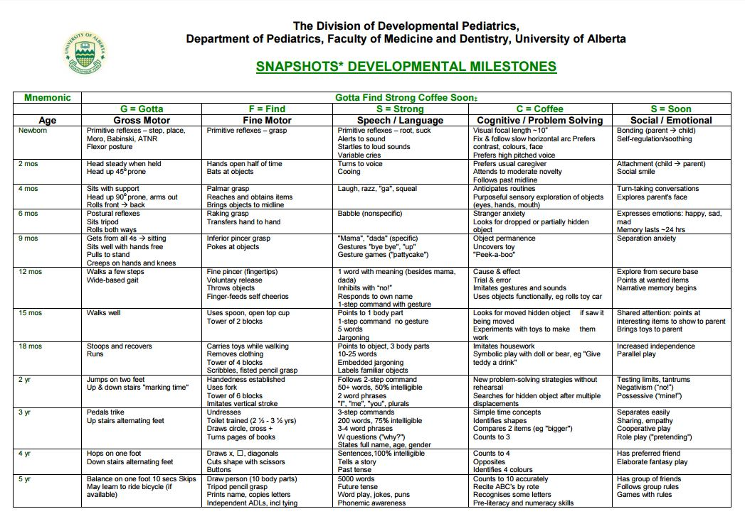
During the early years of adolescent development, they are just starting to begin to grasp the concept of abstract/ logical thought. They are just starting to think about ones actions and what affect it will have on others. This enhanced awareness will often turn into self-consciousness and can lead to the feeling of awkwardness. One’s moral code is also starting to develop during this stage. Before, they were always told what was right and what was wrong by their parents but now they are starting to decide that for themselves.
During school, they are starting to see schoolwork that is more challenging and they often begin to see areas that they are strong at and areas they are weak at. With that being said, clinicians and parents need to be aware of the child’s capabilities and if any are present, identify impediments. If there are any impediments to learning, then the parents and clinicians can take the right course of action to help to child get whatever help they may need to receive the best education they can.
Physical Therapy when working with this type of group should be focused more on play and games rather than exercises. What this does is that it gets the child involved and more active in wanting to do physical therapy. If we make it a game when doing exercises then the child is more likely to participate and give more effort. We should also direct treatment to activities that the child likes to do to improve involvement. Overall, Physical Therapy should be directed to what each child enjoys and what will get them to participate as well.

References:
(n.d.). Retrieved from https://www.pedscases.com/developmental-milestones
Adolescent Development - Pediatrics. (n.d.). Retrieved from https://www.merckmanuals.com/professional/pediatrics/growth-and-development/adolescent-development

Summary of didactic education for this population (20 pts)
Summarize didactic course work and provide 2-3 artifacts with a description of how each it demonstrates mastery of the covered course competencies for the pediatric/adolescent population. Include a summary of service learning opportunities working with this population.
Include course, Course # & Assignment/Assessment Title) Try to show development by using a 1st year course and a 2nd year course.
List and describe each artifact and explain how it demonstrates mastery of this competency. Attach or copy the artifact in the e-portfolio.
(Include a minimum of two textbook references)

Artifact 1: Functional Five Movement Screen (Therapeutic Exercise #21031)

For the first artifact, we as a class went over to Parkview Middle School for a couple days to assess and see the functional development of the middle school students. Below are all the 5 components that make up the screen and goes further into detail about each one individually.
Functional Five Movement Screen
SCORING OVERVIEW:
The scoring rubric helps breaks down each movement into 3 levels. If students are scored at a level 2, their movement pattern is proficient. These students have mastered this baseline movement enough to add more advanced movements to it. Level 3 is the highest score possible. It is not easy to perform. Most kids will not make it into this category and why it is classified as advanced. If students score at a level 1, they need some extra support to re train the functional movement pattern screened. The corrective exercise programming will help students reestablish the mobility, stability or coordination movement pattern weaknesses.
SCORING LEVELS:
Level 3 – Advanced
Level 2 – Proficient
Level 1 – Developing
DYNAMIC KNEE STABILITY – DYNAMIC BALANCE
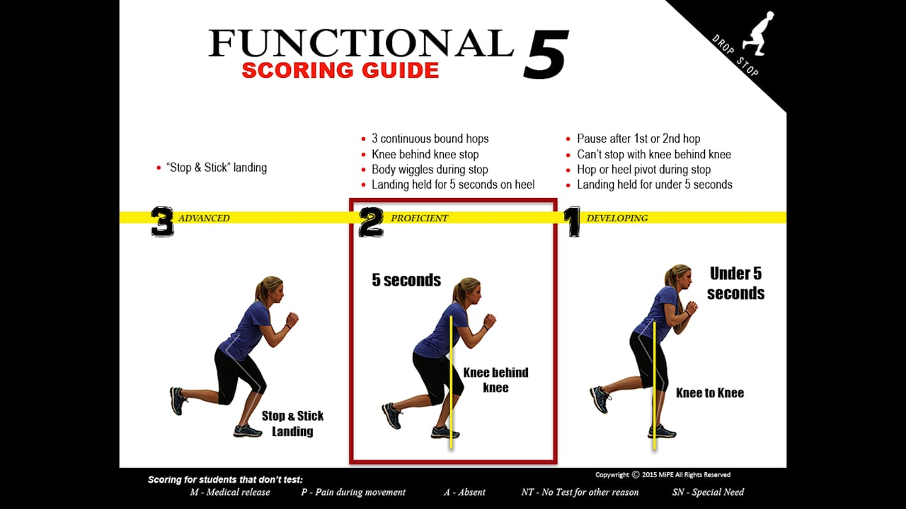
SET-UP DETAILS:
- Students stand on the 9 foot line
- On command, the students hop forward 3 times without pausing
- After the third hop, the students bend and stop
- The landing is held for 5 seconds
- After the first attempt, the students turn around and perform the same movement again
- Two attempts are given on each leg to achieve the highest score
SQUAT SCREEN – ANTERIOR HIP MOBILITY
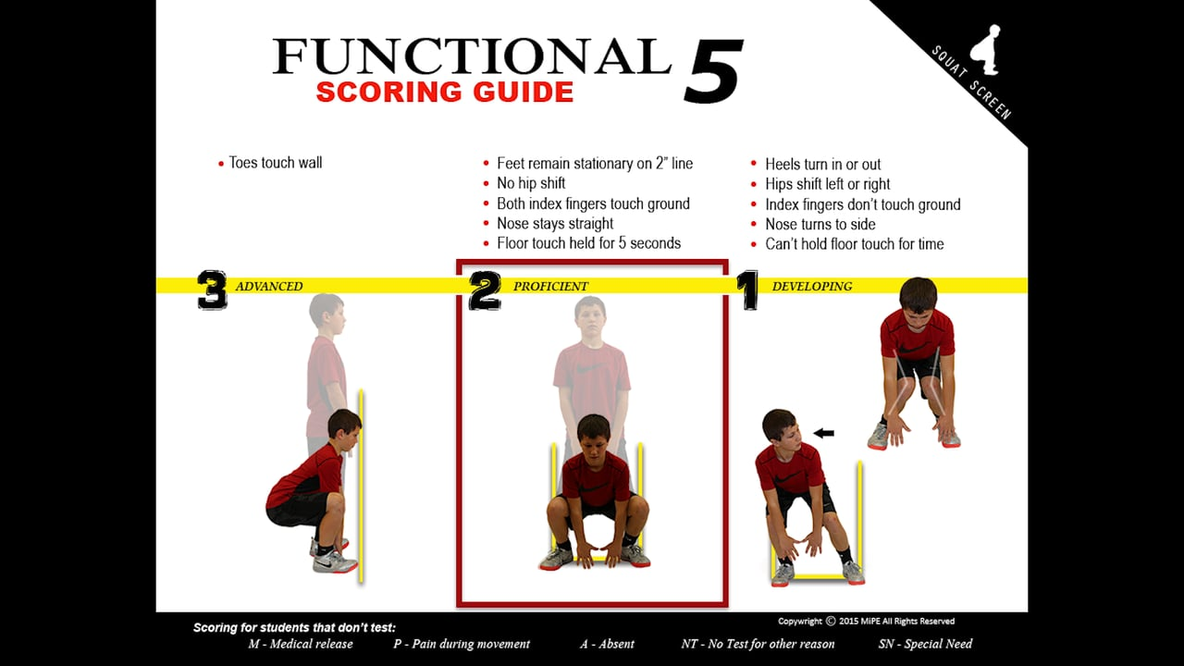
SET-UP DETAILS:
- Students walk up to the wall and place both feet behind the two-inch line
- Feet are shoulder width apart with the toes straight
- Hands point down with the thumbs touching
- On the teachers command, students bend down and touch the ground between the feet
- The position is held for 5 seconds with both index fingers touching the ground
- Once the downward movement is complete, students stand back up and hold the finish for 2 seconds
LEVEL 3 SET-UP DETAILS:
- Students walk up and place both toes against the wall.
- Feet are shoulder width apart with the toes straight
- Hands point down with the thumbs touching
- On the teachers command, student’s bend down and touch the ground between the feet
- The position is held for 5 seconds with both index fingers touching the ground
- Once the downward movement is complete, student’s stand back up and hold the finish for 2 seconds
HIP HINGE – POSTERIOR HIP MOBILITY
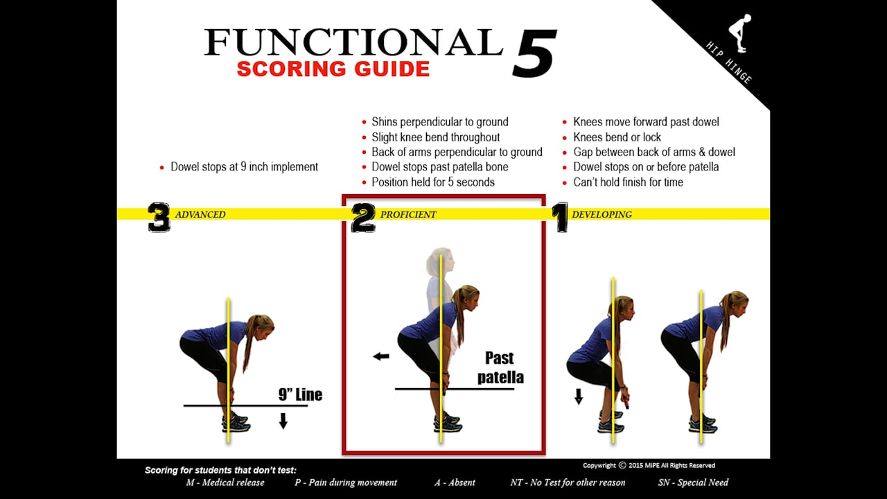
SET-UP DETAILS:
- The students stand nice and tall
- Feet are shoulder width apart with the toes straight
- Knees are and must remain slightly bent
- The students grip the dowel just outside the legs
- The dowel is placed on the quads
- On command, students bend at the hips and slide the dowel down the legs
- The movement stops when the dowel moves past the knees
- The position is held for 5 seconds
- Students then return to the starting position
LEVEL 3 SET-UP DETAILS:
- The students stand nice and tall
- Feet are shoulder width apart with the toes straight
- Knees are and must remain slightly bent
- The students grip the dowel just outside the legs
- The dowel is placed on the quads
- On command, students bend at the hips and slide the dowel down the legs
- The movement stops when the dowel contacts a 9 inch implement
- The position is held for 5 seconds
- Students then return to the starting position
CORE STABILITY – POSTURE SCREEN
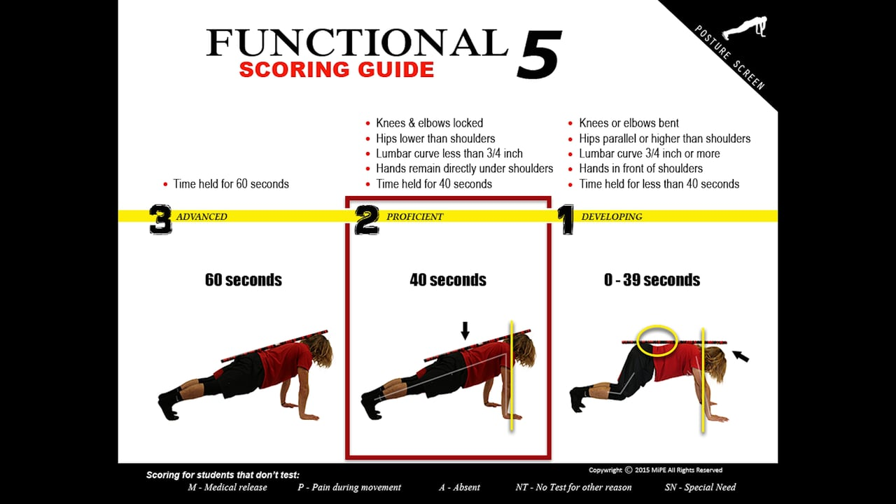
SET-UP DETAILS:
- Students set-up on all fours
- Knees are bent
- Hands are placed directly below the shoulders
- The chin is tucked
- A dowel is placed on the head, upper back & tailbone
- On command, students raise and lock the knees keeping the hips lower than the shoulders
- Students hold for time
MOVEMENT ADEQUACY – SKIP SCREEN
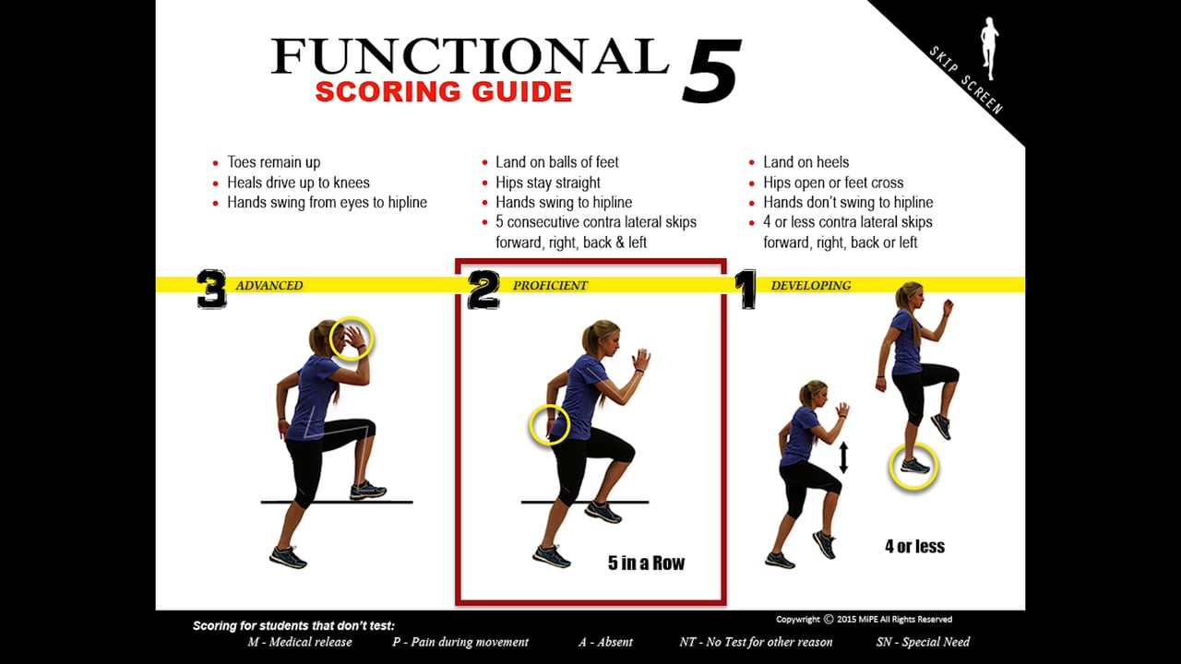
SET-UP DETAILS:
- Students stand nice and tall.
- On command, students skip forward, right, backward and left 5 times in each direction
SCORING OVERVIEW:
The scoring rubric helps breaks down each movement into 3 levels. If students are scored at a level 2, their movement pattern is proficient. These students have mastered this baseline movement enough to add more advanced movements to it. Level 3 is the highest score possible. It is not easy to perform. Most kids will not make it into this category and why it is classified as advanced. If students score at a level 1, they need some extra support to re train the functional movement pattern screened. The corrective exercise programming will help students reestablish the mobility, stability or coordination movement pattern weaknesses.
Competencies:
- #1 Integrate concepts of pathology, PT intervention and data collection for application to adolescent population (7D2, 7D4, 7D5, 7D8, 7D16, & 7D29)
- #5 Differentiate typical/atypical development (7D24i)
- #6 Describe development tests used to assess children (7D24i)
- #7 Explore the role of the PTA in the promotion of health & wellness and prevention for the pediatric & adolescent population (7D24m)

Artifact 2: HEP for Middle School Student (Musculo Rehab #81550)
HEP for Middle School Student
Since my student scored 1’s on each of the tests, I had to make his HEP very simple to do and start off with the basics.
HEP #4: Jacob G

Hamstring Stretch with Towel

While lying down on your back, hook a towel or strap under your foot and draw up your leg until a stretch is felt under your leg/calf area.

Keep your knee in a straightened position during the stretch and hold for 30 seconds
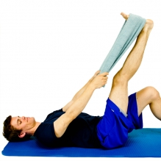

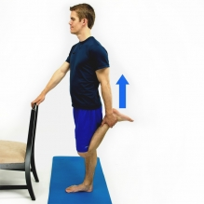
Quad Stretch

While in a standing position, bend your knee back behind and hold your ankle/foot. Next gently pull your knee into a more bent position until a stretch is felt on the front of the thigh.

Hold for 30 seconds and then switch to the other leg.

Single Leg Stance

Stand on one leg and maintain your balance

Hold for 30 seconds and then switch to the other leg.
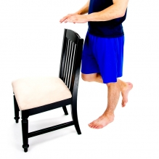
Modified Plank Plus

Perform a plank on your knees and elbows as shown.

Hold for 30 seconds and then relax. Do 3 sets of 30 seconds.
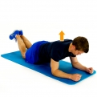

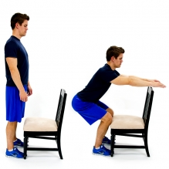
Squat – Chair as Guide

While standing with your feet shoulder width apart and in front of the chair that is facing you, Bend your knees and lower your body towards the floor. The chair seat is a guide so that your knees do not pass over your toes.

Do 3 sets of 6 reps

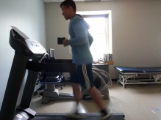
Running on a treadmill or around the block

Jog for 10 min.

Do this twice a day.

Reflection:
I decided to educate Jacob and his parents on how to stay active as a kid. I believe it’s very important, especially in today’s world with all the electronics and gaming systems out there that kids are not being as active as they used to be and is causing a lot of problems health wise. The reasons why I chose these exercises was because my kid scored all 1 on the functional 5 tests. This could be due to lack of effort or because he truly scored all 1’s. To start him off, I gave him a couple of stretching exercises so that he can improve his range of motion and mobility so that he can have more success the next time he is tested for the functional 5. I also have him working on balance exercise so that he can improve on his drop step. I also have him working on his core with the mini plank so that he can start to learn good form first. Lastly, I have a jogging program for him so he can start to improve in cardiovascular system and be ready for the pacer test.
If Jacob said they are doing okay with the exercises that was sent home with them, I would start to progress these exercises. I would do this by either increasing the reps and sets for the exercises that it applies to or increase the time. I believe for Jacob, he needs to work on more stretching and mobility exercises as well as improving the cardiovascular systems if he wants to see improvement in his scores.

Competencies:
- #2 Integrate concepts of pathology, PT interventions and data collection for application to adolescent populations. (7D2, 7D4, 7D5, 7D8, 7D16, 7D29)
- #7 Explore the role the role of the PTA in promotion of health & wellness and prevention for the pediatric & adolescent population (7D24m)
- #9 Explore physical therapy interventions for special patient populations. (7D2, 7D4, 7D5, 7D8, 7D16, 7D24e,7D29)

Provide two clinical case descriptions from clinical experiences with this population (20 pts)
A description of at least 2 patient cases, showing/describing where they fit into the spectrum of various developmental areas. Provide Examples of treatment that has or could be done with these patients that would be appropriately tailored to their unique place in the developmental spectrum. Emphasis should be placed on noting the ways therapy interventions, data collection, and communication have been modified to fit each patient case

*Document any additional learning opportunities experienced in the clinic for this age group. (Observe surgery, give in-service, attend in-service or training, aquatic therapy, etc)

The first patient that I saw was during my first round of clinicals at Prevea Health and the girl was recovering from a torn ACL and was towards the end of Physical Therapy. Since it was my first week there, I was more just observing and entering in data. The PT I was with was making the test that she had to pass to be able to return to sports fun and competitive so that it would peak her interest. The PT also made it more competitive by challenging her to beat her previous scores so that it shows that she was improving since coming to Physical Therapy. These tests included the Single Hop Test, Triple Crossover Test, One Leg Rise Test, and the 6 Meter Timed Hop Test. The PT that I was with was not my original CI and I only was able to work with this patient one time but I learned a lot just by observing. Unfortunately the patient was getting exhausted and tiring out that the PT terminated the rest of the test for safety reasons. I was happy to be given the opportunity to witness this treatment and how well the PT interacted with the patient.
The second patient I saw was during my second round of clinicals at the Wellness center. The pt was a young girl who had just suffered a patella bone contusion. For this pt, I was able to lead the entire treatment for 45 min. Since it was the first time I was working with her, she was very shy and quiet. To get her started, I started her on the bike and to get her to warm up to me, I was asking what all happened and how she got hurt. She told me that it was during one of her soccer games and that a girl from the opposite team had kicked just below the knee while she was trying to score. That’s when I said “Well did the other girl get a red card for trying to take out the best player on her team” and that got a chuckle from her. Just like that, she wasn’t shy anymore and was willing to do all the exercises that did for that treatment. We mainly worked on Isometrics, SAQ, US and Clamshells to reduce the swelling and get blood moving to promote healing.
Both of these patients were on the opposite ends of the stages of healing since the first one was in the chronic phase while the second one was in the acute phase. Each patient will be different and as a PTA, you just have to tailor your treatment to best fit each patient.

Explore the role of the PTA in promotion of health & wellness and prevention for the pediatric & adolescent population. (10pts)
How would the PTA promote health & wellness for this population? What is the focus/benefit for this population? Provide examples of programs and educational information for this population.
Use resources: List resources in the capstone and provide links to resources in e-portfolio
(Include a minimum of two resources)
Possible resources (textbooks, websites, videos, programs, etc)

The role of a PTA can help promote being healthy and wellness for the younger population by doing multiple things. We can encourage them to start playing in the backyard, riding bikes with friends or going to play sports with friends. Today’s generation likes to stay inside and play videogames or play with electronics, which can hurt their health based on how common they stay inside. Too much screen time can not only affect the weight management but can also have negative effects on cognitive development, psychological health and sleep cycle. We can educate them that playing outside can have positive effects that they might not even know of. For example, it can build strong bones and muscles, improve balance, develop flexibility, improve posture and improve cardiovascular fitness. When explaining these things to this type of group, in particular the pediatrics, it’s important to explain it in terms that they will understand. When talking to the parents, it’s important to encourage them to enlist their child in an active after school activity like sports. This way, the child will become more involved and make friends that also like to do whatever interests them. If a child has another friend who also likes whatever activity they do, it also provides incentive to want to go to that activity to see their friend.

References:
Get Active Each Day. (n.d.). Retrieved from https://www.healthykids.nsw.gov.au/kids-teens/get-active-each-day
Sharman, R. (2019, February 22). Too much screen time and too little outside play is holding back kids. Retrieved from http://theconversation.com/too-much-screen-time-and-too-little-outside-play-is-holding-back-kids-31116

Explore physical therapy interventions for pediatric/adolescent special patient populations. (10pts)
Explore interventions for Autism plus one other pediatric special population (ADHD). Include information regarding the role of the IDEA (Individuals with Disabilities with education Act) and school based physical therapy
Use resources: List resources in the capstone and provide links to resources in e-portfolio
(Include a minimum of two resources)
Possible resources (textbooks, websites, videos, programs, etc)
Autism
The pediatric/adolescent populations who have Autism can expect to have disorders in low muscle tone, balance, difficulty with running/kicking/throwing and even activities of daily life. As a physical therapist assistant, there are many things we can do with this type of population that would help to improve ADL’s, coordination and muscle strength. One main goal to keep in mind especially when working with young ones is to make the desired intervention FUN and ACTIVE so that they are willing to participate and see goals being reached. For example, for coordination activities like ball-catching try and make it a competition between you and the child so that they can be a little bit competitive and want to participate. For balance try and make it seem like the floor is “lava” and they have to stay upright otherwise they would fall in. For strengthening exercises, try to make it fun by trying to see how much their muscle grows and always encouraging them. “Most of the time, physical therapy is included in early intervention programs offered by school districts and other local providers.” (Rudy). In school, this special population has access to Physical Therapy. This is all possible due to the Individuals with Disabilities Education Act (IDEA). IDEA is a federal law that requires schools to provide educational needs to students with disabilities (Lee).
ADHD
The pediatric/adolescent populations who have ADHD can expect to have hyperactivity or impulsive behaviors that interferes with motor function and development. Physical Therapy has been shown to decrease anxiety, stress and any depressive symptoms found in children with ADHD. Studies show that with moderate to high intensity training, motor performance and information processing will improve. Examples of exercises that will get them to that moderate to high intensity are playing sports, swimming and riding bikes. Yoga is another alternative that has been proven to improve attention in children with ADHD. As long as the child is achieving the right intensity, there will be improvements with lack of focus, social skills and less impulsiveness.
References:
Attention Deficit Disorders. (n.d.). Retrieved from https://www.physio-pedia.com/Attention_Deficit_Disorders
Lee, A. M., & J.d. (n.d.). Individuals With Disabilities Education Act (IDEA): What You Need to Know. Retrieved from https://www.understood.org/en/school-learning/your-childs-rights/basics-about-childs-rights/individuals-with-disabilities-education-act-idea-what-you-need-to-know
Rudy, L. J. (n.d.). What Can a Physical Therapist Do for a Your Autistic Child? Retrieved from https://www.verywellhealth.com/physical-therapy-as-a-treatment-for-autism-260052

Total Points Possible (100pts)

