- Geriatric Population Section
#4 Integrate concepts of pathology, PT interventions and data collection for application to geriatric populations. (7D2, 7D4, 7D5, 7D8, 7D16, 7D29)
#7 Explore the role the role of the PTA in promotion of health & wellness and prevention for the geriatric population (7D24m)
#8 Determine patient re-integration to home, community, and work environment for the geriatric population(7D24m)
#9 Explore physical therapy interventions for special geriatric patient populations. (7D2, 7D4, 7D5, 7D8, 7D16, 7D24e,7D29)
Lifespan Systems Approach for the Geriatric Population (Group Project) (10pts)
Describe the major changes, functional implications, rehabilitation implications for each life stage. How with this knowledge be integrated as a PTA when treating patients from this age? (Nervous, Somatosensory, Visual, Vestibular, Muscular, Skeletal Systems)
The Nervous System
Age Stage | Major Changes | Functional Implications | Rehabilitation Implications
Aging (Older Adult) | Continued growth of dendrites into old age  Decreased number of neurons, especially in higher-order association area  Decrease in temporal and frontal lobe volume  Decrease in size of brainstem and cerebellum  Myelin loss with consequent velocity and slowed neuronal processing | Higher-level cognitive functioning declines and memory deficits increase  Reaction time decreased, reflex responses slowed, acuity of senses decreased and motor performance diminished  Basic intellectual ability maintained until at least age 75 | Learning continues to be possible well into old age  Due to maintained plasticity, functional decline not evident until critical threshold of cell loss/shrinkage is crossed  Acquisition of new information and conversion of new information from working memory to long-term memory is significantly declined  Balance problems

The Somatosensory System
Age Stage | Major Changes | Functional Implications | Rehabilitation Implications
Aging (Older Adult) | Number of receptors decreased, structural distortion of receptors, proprioceptors atrophy, and weakening of impulse conduction occur  Skin changes such as wrinkling, increased toughness, and changes in hair distribution affect accuracy of reception | Tactile sensitivity decreases, especially fine touch, pressure, and vibration sense, predominately in fingertips, palms, and lower extremities  Decrease in feedback to CNS secondary to proprioception loss, contributing to movement inaccuracies, instability, incoordination, gait disturbances, and falls | High incidence of peripheral neuropathy  Need to compensate with additional sensory or external cues  Need to make purposeful, more deliberate movement

The Visual System
Age Stage | Major Changes | Functional Implications | Rehabilitations Implications
Aging (Older Adult) | Eye structure changes so that less light is transmitted to the retina and pupil size decreases  Both macular degeneration and cataracts are common  Visual acuity decreases between the ages of 60 and 80; at 80% of normal at age 85 | Because less light is transmitted, visual threshold is increased, requiring more light to see  Ability to adapt when moving from a dark to a light environment decreases and incidence of glare is high  Depth perception, contrast sensitivity, and peripheral vision decline | Significant implications for safety, mobility and functional independence  Older adults may require additional sensory or external cues, especially when in unfamiliar environments  Clinicians should be aware approximately 10% of elderly persons have undetected eye disease or visual impairment

The Vestibular System
Age Stage | Major Changes | Functional Implications | Rehabilitation Implications
Aging (Older Adult) | Age-related changes include reduction in number of receptors and motor fibers, loss of hair cells  Centrally, vestibular nuclei have decreased electrical deterioration in central processing | Decline in vestibular abilities contributes to postural control deficits  Incidence of dizziness, vertigo, unsteadiness, and balance disorders increases  Increased threshold for vestibular activation could contribute to increased body sway | Ability to function adequately in new or unfamiliar environments, or where other sensory cues are unpredictable, decreases  Falls in the elderly are caused by a constellation of factors, including decline in vestibular functioning

The Muscular System
Age Stage | Major Changes | Functional Implications | Rehabilitation Implications
Aging (Older Adult) | Senile muscular atrophy occurs, due to decrease in fibers, decrease in muscle mass, and decline in number of functional motor units | Strength and speed of muscle contraction decrease, 50% loss by age 70  Rate of decline in muscle strength less in upper extremities than in lower extremities, this distribution contributing to changes in postural alignment and perhaps causing functional instability  Trunk weakness may contribute to less effective equilibrium reactions | Degree of atrophy highly variable, dependent on activity level and level of fitness  Strength losses can be minimized with exercise, including moderate weight training  Rehabilitation program success is highly dependent on premorbid fitness level

The Skeletal System
Age Stage | Major Changes | Functional Implications | Rehabilitation Implications
Age (Older Adult) | Collagen is less elastic and slower to respond to stretch changes  Loss of bone mass continues | Loss in flexibility may contribute to hypokinesis  Declines in both strength and flexibility can contribute to poor posture | Range of motion can be maintained but stretch needs to be done more slowly  Incidence of osteoporosis and osteoarthritis is high  Age-related bone loss decreases with physical fitness, including moderate weight training

Life Span Developmental Issues: Implications for the PTA
Psychosocial Development in the Older Adult Population (Table 4-1) p.93-94) (10pts)
Age Stage | Psychosocial Cognitive Stage | Developmental Task/Key Issues | Important Influences | How can your interaction as a PTA express sensitivity to these key issues? (Specific)
Older Adult | Integrity vs. Despair | Coming to terms with the meaning of life; facing mortality and potential despair; feeling satisfaction with one’s life | Supportive family, friends, religious and community support  Need for sense of wholeness and vitality; wisdom | Acknowledging beliefs  Patience  Positivity and honesty  Education and integration of community support groups

Summary of Older Adult Development (10pts)
A summary of the information on various aspects of development from your textbook/online resources. You should include, functional abilities, psychosocial development, etc Specifically address how interventions and communication should be tailored to this population
The geriatric population consists of those who are 65 years of age and older. The functional abilities that you should expect from this population is a decrease from what they could do while in the adult phase. One can expect a decrease in memory, strength, flexibility, hearing, visual field and physical activity. While working geriatrics, a PTA can expect to use a slow yet loud voice with them because they can’t quite process information as quick as they used to. That and their hearing is also not as good which is why we speak a little louder to make sure they hear us. Exercises should be explained thoroughly and demonstrated so that it reinforces learning. They should also receive a print off of the exercises to help them remember what to do since we can expect a decline in memory from them as well. With that being said, we also want to make our treatment as functional as possible so that they can return to where they were before. For cardio exercises, walking works best with this population. We also have to keep in mind what they like to do so we can tailor it to help enforce them doing the exercises. In general, we have to take our time when working with geriatrics.

Summary of didactic education for this population (20pts)
Summarize didactic course work and provides 2-3 artifacts with a description of how each it demonstrates mastery of the covered course competencies for the Older Adult population. Include a summary of service learning opportunities working with this population. Include course, Course # & Assignment/Assessment Title) Try to show development by using a 1st year course and a 2nd year course.
Include course, Course # & Assignment/Assessment Title) Try to show development by using a 1st year course and a 2nd year course.
List and describe each artifact and explain how it demonstrates mastery of this competency. Attach or copy the artifact in the e-portfolio.

Keep stepping Handout
I chose to do the keep stepping handpout as my first artifact because both of my clients that I worked with were in the geriatric population and I was really able to get close and work with each person one on one. I was able to figure out what impairment each one had and ways to go about correcting it or to strengthening it. This was over the course of a semester with each patient and I not only was I able to see progress in each patient but they did as well. The course competencies covered for this project are listed below.

PTA Applied Kinesiology #81040
Competencies:
- Explore the role the role of the PTA in promotion of health & wellness and prevention for the adult population (7D24m)
- Explore physical therapy interventions for special patient populations. (7D2, 7D4, 7D5, 7D8, 7D16, 7D24e,7D29)

What is a Circuit
- Circuit training is where we will have 6 differents stations with a different exercise at each station. At each station you will work out for 1 min. and 30 sec then have 45 sec. to move to the next station. 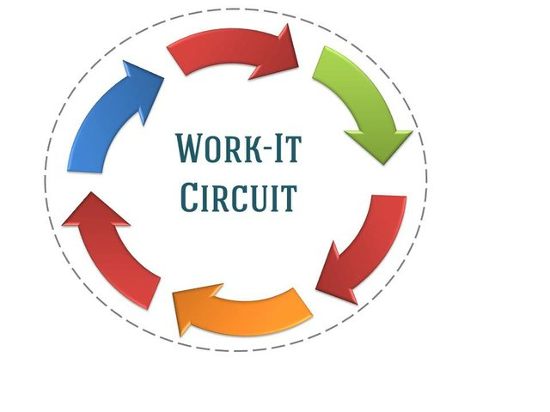
Benefits of Circuit Training
- A circuit based exercise program is designed to get you up and moving, to get your heart rate up, along with strengthening.
- With different types of training it keeps you active so you won’t get bored.
- It is a great way to incorporate a full body workout in a limited amount of time.
Station 1: Upper Extremity Strength
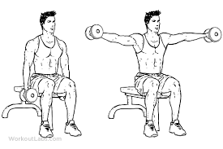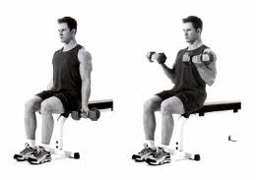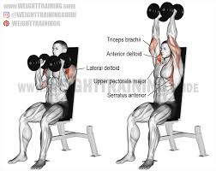
Station 2: Lower Extremity Strength
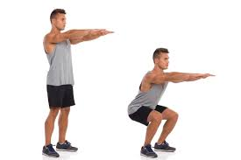
Station 3: Core Strength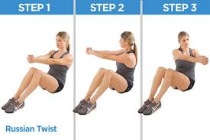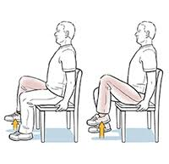

Station 4: Balance and Coordination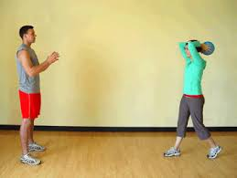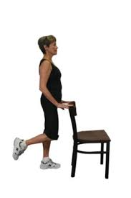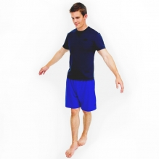

Station 5: Cardio Endurance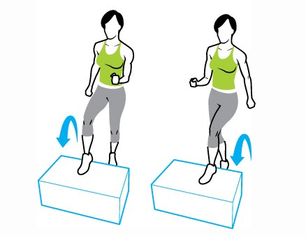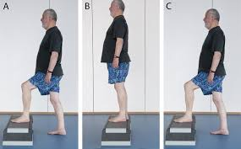

Station 6: Back Strength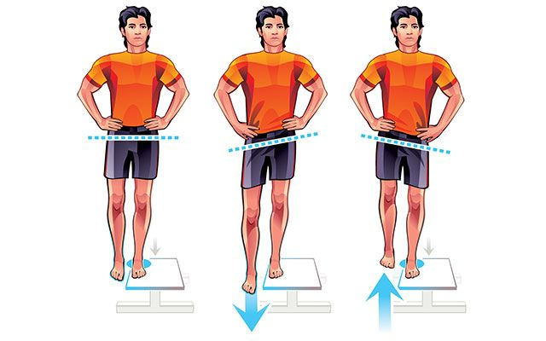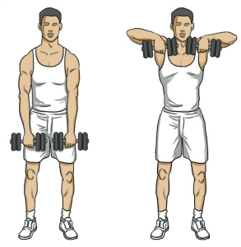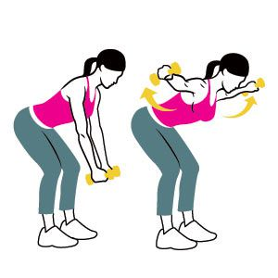

Home Assessment
The second artifact that I chose was the home assessment I did on my grandma and her house. This fits perfectly with the geriatric portion because she is 85 years old and has possible safety issues with her house. After going through it with her and being able to show her simple fixes that didn’t need a lot of money, both she and I were able to see improvements. These improvements helped to make her safer in her own house for when I am gone next year back in Arizona. The course competencies covered for this project are listed below.
PTA Rehab Across the Lifespan #21117
Competencies:
- Explore the role the role of the PTA in promotion of health & wellness and prevention for the adult population (7D24m)
- Explore physical therapy interventions for special patient populations. (7D2, 7D4, 7D5, 7D8, 7D16, 7D24e,7D29)

Casey Tompa
Home Assessment
Rehab Across the Lifespan
4/25/2019
Home Assessment
I decided to do my home assessment on my grandmother’s house in Green Bay. My grandma is 85 years old and currently lives with me in a two-story house that is made up of the first floor and the basement. My grandmas past medically history is that she has had breast cancer and blot clots before. She is now cancer free but is on warfarin, which is a blood thinner so that a blot clot does not develop again. Sadly with her old age, her memory isn’t the best at all and often forgets to do a lot of things whether its going to appointments or what my schedule is since I am currently living with her in the basement while I am out here for school. I have to repeat myself several times if I have to go to the clinic down in Sheboygan today or to my job that I work on the weekends at 1919 Kitchen & Tap. Mobility and strength wise, she has no impairments but cognitively there are. The home assessment tool that I used is called a “Safe at Home Checklist”.
The first problem that I saw the house had to do with her bathroom, specifically the bathtub. To get into the bathtub, it is a high step over and I often hear my grandma complain about it when she has to take a shower. A simple solution to fix this would be to add a small step stool in with added handrails for security. An expensive solution would be to tear down the old bathroom and put in a step in shower with a shower seat for her to sit in so she doesn’t have to stand the whole time. This eliminates the need to step over to get in and allows her to sit down which can help with stability.
The next problem that saw had to with the kitchen. First, I opened the cabinet under the sink to find that the pipes were not covered or insulated. There is a simple fix to this which is to cover the pipes with the correct material needed. An expensive solution is not required for this. Another problem that I saw is the rug in front of the sink, which is really thick and I have seen my grandma trip over it numerous times. Not only that but it never stays in place and moves around quite easily. A quick fix to this would be to apply double sided tape or non slip pads on the corners of the rug so that it doesn’t move around on her. An expensive route could be to go out and get a new rug altogether that is not as thick and comes with stick pads.
The last big problem I noticed had to do with the basement. To get down into the basement, the stairs are poorly lit because there is light only at the top and bottom of the stairs and not middle. Thankfully grandma hasn’t taken a tumble down the stairs but a light should be added in the middle. There is not really a cheap option to do this since an electrical wire would have to be made and cut into the ceiling to allow for an extra light fixture. The stairs also only have railing on one side and it would be ideal if they were on both sides for extra protection. Lastly is the light in the laundry room/storage area in the basement. This room has only one light and even it tis bright, it only covers the washer and dryer and not storage area. A simple fix to this would be to buy one or two stand up lamps to be able to have more light throughout the room. An expensive fix to this would be to have an electrician install a whole new light system throughout the room.
Overall, my grandma moves pretty well for her age but can have set backs with her memory and her medication. While there were a lot of great ideas on the assessment checklist I used, it is out of the question due to money reasons. For those problems that I could fix with simple/ quick fixes, I did. I enjoyed doing this assignment and going over the possible issues with my grandma so that not only I was aware but she was too.

Provide two clinical case descriptions from clinical experiences with this population (20 pts)
A description of at least 2 patient cases, showing/describing where they fit into the spectrum of various developmental areas. Provide Examples of treatment that has or could be done with these patients that would be appropriately tailored to their unique place in the developmental spectrum. Emphasis should be placed on noting the ways therapy interventions, data collection, and communication have been modified to fit each patient case.
*Document any additional learning opportunities experienced in the clinic for this age group. (Observe surgery, give in-service, attend in-service or training, aquatic therapy, etc)

The first clinical case that fits with this population was during my last clinical at the hospital acute setting. We had this male 70 year old patient who was getting one of his knees replaced. I was able to watch his total knee replacement surgery the day before working with him which lasted about 45 min. It’s a very interesting process watching them up close and all and how invasive the surgery is. After the surgery they go to a recovery room for a couple hours and then the Physical Therapist gets them up and moving on the same day. The next day is where I came in and made sure he was able to do his exercises, go for a walk, do the stairs to make sure he could get into his house and teach him how to transfer in and out of a car. If he could do all these things safely then I would graduate him and discharge him from physical therapy until he had to go for out patient therapy. In the end, he did everything safely and I was able to send him back home with his wife.
The second clinical case that fits with this population was during my last clinical at the hospital as well. She was a 86 year old female who came in due to a UTI and had a general decline in muscle strength. For her I gave her 4 exercise to help with strengthening the lower extremities. The first exercise was the quad set to help strengthening the muscles that deal with standing up and down. The next exercises was the heel slides followed by snow angles (Hip abd/add). Lastly, I gave her hip external and internal rotation exercises to keep the hip joint nice and flexible. I saw her over the course of a couple days and she said herself that she could feel herself getting stronger.
Explore the role the role of the PTA in promotion of health & wellness and prevention for the geriatric population (7D24m) (10 pts)
How would the PTA promote health & wellness for this population? What is the focus/benefit for this population? Provide examples of programs and educational information for this population.
Use resources: List resources in the capstone and provide links to resources in e-portfolio
(Include a minimum of two resources)
(Possible Resources (textbooks, websites, videos, programs)

My job as a PTA is to promote promotion of health and wellness and prevention for the geriatric population. There are plenty of ways to do this but I personally think increasing physical and mental fitness is what’s best for this population. Staying physically active improves emotional health and how you feel. Also with this population, they mentally start to decline and slow down thought processing wise. By working on these two factors alone, patients can start to see health benefits and are able to maintain a functional independence. This can be achieved by going on walks with friends or joining fitness classes. Another important factor that should be included with this population is the vitamins they should be taking. Vitamin D is important for them to have so that it can increase the absorption of calcium which helps to make bones stronger. With their age, they can easily fracture or break bones from falls. Another important vitamin is Calcium as stated above to help make bones stronger. In general, getting them up and active is what will help them in the long run.
References
Organization, C. R. (n.d.). Health and Wellness Promotion For Older Adults. Retrieved from https://chiro.org/research/ABSTRACTS/Health_and_Wellness_Promotion.shtml
The Only 5 Supplements Older Adults Need to Know. (2018, September 19). Retrieved from https://www.silversneakers.com/blog/supplements-older-adults-need-know/

Summarize the role to the PTA in determining reintegration to the home, community and work environment. (Use textbooks and handouts to summarize Home assessment and re-entry into the community & home) (10pts)
Home Assessment-describe the role of the home assessment (purpose/function) for the geriatric patient. What are some assessments tools? How is this information incorporated into physical therapy interventions?
The role of the home assessment for a geriatric patient is to evaluate the persons functional ability, physical health, cognition and mental health. Some examples of assessment tools are using a checklist to see if the patient’s home has rails for stairs, any tripping hazards, making sure pipes are covered, lighting in house, etc… Once hazards have been identify, they can start to go and correct it so that they are safer in the house. This information can be incorporated into physical therapy interventions by improving strength for those that are weak or increasing endurance like walking for those that fatigue easily. Home assessment are an important tool for those that live by themselves and do not often have help al the time.
References
Elsawy, B., & Higgins, K. E. (2011, January 01). The Geriatric Assessment. Retrieved from https://www.aafp.org/afp/2011/0101/p48.html
ADA accessibility guidelines (ramps, landings, turning radios, door widths, hall widths)
ADA accessibility guidelines are mainly used by businesses’ and corporations to make sure their building is accessible to those with disabilities. They are responsible to developing and updating design guidelines for the buildings. Our role as the PTA would be to educate the patients on what is acceptable and what is not. We can also educate them on how to go up ramps and how they should turn. We can also teach them how to correctly use their assistive device.
References
Yanchulis, D. (n.d.). Home. Retrieved from https://www.access-board.gov/guidelines-and-standards/buildings-and-sites/about-the-ada-standards

Death & Dying; Hospice, Stages of Grief
When working with this type of population, its important to understand that the role of the PTA is to focus on caring and not trying to cure or correct their deficits. We want the patients to feel that they still have their pride and dignity. Each patient will go through different stages of grief and its important that we as the PTA are there to listen and provide comfort. Just listening and being a person for the patient to vent to can mean the difference to them. They know that their time is coming to an end but it helps to know that they aren’t doing it alone.
References
Hospice Care. (n.d.). Retrieved from https://www.nhpco.org/about/hospice-care

Use resources: List resources in the capstone and provide links to resources in e-portfolio
(Include a minimum of two resources)
Possible resources (textbooks, websites, videos, programs, etc)

Explore physical therapy interventions for older adult special patient populations. (10 pts)
Explore interventions and treatment strategies for a patient with Dementia plus one other geriatric special population. Include information regarding the role of the ADRC and other resources for the geriatric population. Examples of other special populations could include chronic health conditions and progressive neurodegenerative conditions.
Use resources: List resources in the capstone and provide links to resources in e-portfolio
(Include a minimum of two resources)
Possible resources (textbooks, websites, videos, programs, etc)

Dementia
Dementia can be diagnosed for someone who starts to show a decline in their mental ability, which then affects and interferes with activities of daily living. A form of dementia can be called Alzheimer’s disease. There is not just one specific test that will confirm if one has it or not but rather from collecting data from multiple tests to help pin point the problem. Since dementia cannot be cured, there are ways to manage the symptoms. One way is to take medications such as Cholinesterase inhibitors, which help with memory and judgment. Another way to treat can be done with Occupational and Physical Therapy. Both can help to treat the patient by going back over their activities of daily living and making sure they are able to do everything safely.
Parkinson’s
Parkinson’s disease is a progressive disease that affects the nervous system. A common sign of the disease are tremors, slow and imprecise movement, as well as a rigid musculature. There is also a deficiency of the neurotransmitter dopamine due to the degeneration of the basal ganglia of the brain. Just like Dementia, there is not one specific test that will confirm if you have Parkinson’s disease or not but rather through multiple tests. Medications can be taken to help manage or slow down the disease such as Caridopa-Levodopa. This helps because it is a natural chemical that passes into your brain and converted into dopamine. They can also come to physical therapy to help with exercising. By doing exercises, it can increase muscle strength, flexibility and balance. Not only that but it can help to reduce anxiety and depression.
The ADRC can help with both of these populations because they help the patients get unbiased yet accurate information on the disability they are living with. They are friendly places that go into depth about aging or living with a disability. Not only that but they can provide information on programs and services that tailor to the patients needs.
References
Aging and Disability Resource Centers (ADRC) Consumer Page. (2019, April 23). Retrieved from https://www.dhs.wisconsin.gov/adrc/index.htm
Dementia. (2019, April 19). Retrieved from https://www.mayoclinic.org/diseases-conditions/dementia/diagnosis-treatment/drc-20352019
Parkinson's disease. (2018, June 30). Retrieved from https://www.mayoclinic.org/diseases-conditions/parkinsons-disease/diagnosis-treatment/drc-20376062

